13. React-JS HOL

Name:- Shubham Sangram Bej

Hands-on 13

Objective
- Understand conditional rendering in React.
- Render multiple components on a single page.
- Display lists using the map() function.
- Use React keys while rendering collections.
- Demonstrate conditional rendering techniques.

Software Requirements
- Node.js
- npm
- React
- Visual Studio Code

Project Name
bloggerapp

Procedure
- Created a new React application named bloggerapp.
- Created separate components for Course Details, Book Details, and Blog Details.
- Stored all data inside a separate Data.js file.
- Used the map() function to render lists of books, blogs, and courses.
- Assigned unique keys to each rendered item.
- Implemented conditional rendering using a boolean variable.
- Displayed all three components side by side using CSS Flexbox.
- Executed the application using:
npm start
- Verified the browser output.

Output
The application displays Course Details, Book Details, and Blog Details in three separate columns. All data is rendered dynamically using React components and the map() function.
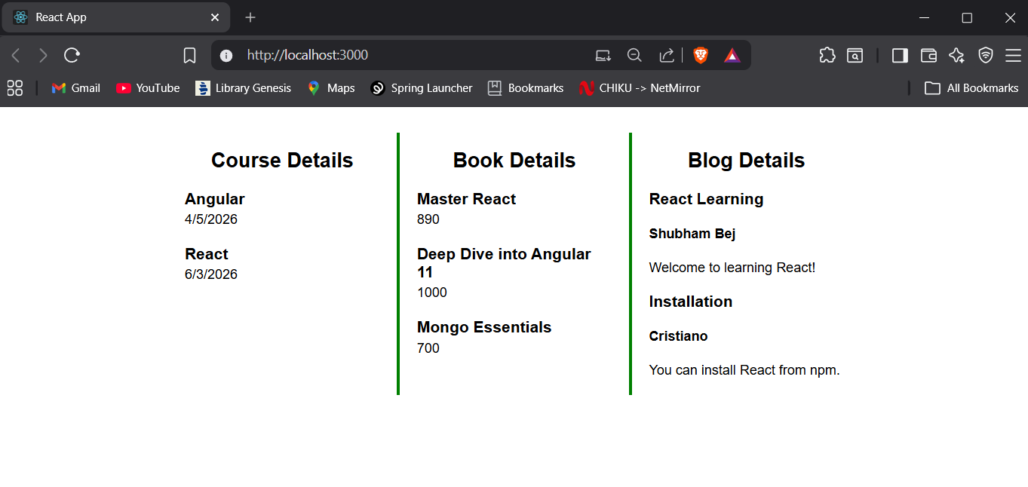

Result
The React application bloggerapp was successfully developed to demonstrate conditional rendering, multiple component rendering, React keys, and list rendering using the map() function.

